Alexandra Ivan, XII C

e-life: reality or illusion?
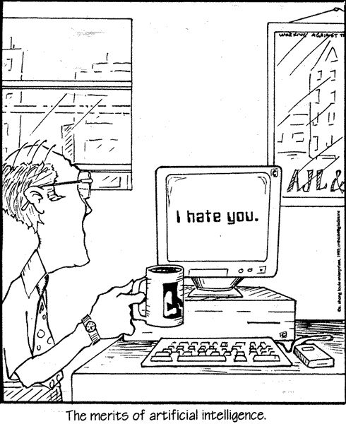
What do you do when life doesn’t rise to your expectations? Can you just press Alt-Ctrl-Del and start over?

Nowadays, the answer seems to be ‘yes’. Through a thin optical fibre, the world comes to your display. The internet can give you almost anything. You can discover the universejust by sitting on your chair. You can tour the Louvre, literally visit Machu Pichu, see the white whale or travel in space. You can meet Einstein, discover the latest scientific breakthroughs and sit gaping at the infinite possibilities the world offers. With a stroke of the keyboard, you can communicate. Others’ opinions will be revealed, you will be proposed new attitudes, philosophies, purposes and opportunities.

In fact, it only seems a computer can give you anything: an ideal to live for, a world to see, a community to belong to. But is this really all there is to life? If you have all this, what more could you wish for?

The word is ‘reality’. The physical sensation of a hug, someone to bring you a hot cup of tea, someone to look for you while you are ill – in a word, the certitude that when you get up from your desk or take off your VR helmet, you won’t stand on the edge of a desert – these are all things a computer cannot generate. In response to your hope and love, all it can give back is an infinite binary string.

At the end of the day, there will be just you and a pile of metal cards. Are you sure that this is what you want?

***

Anca Cretu, XA
Craving

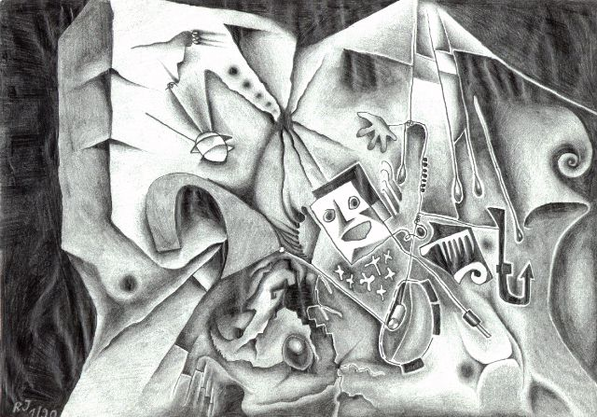
i crave the unknown, the universe, the immensity
i crave a one-dimension world where i can get to know you better
i crave the fulfilment of all our dreams
i crave for the joyful morning to bring you into my way
i crave to bathe in the sun of your smile and your gaze
i crave to dry away the cold crystals of sadness from your eyes
i crave to drive away the vultures of suffering from your heart
i crave all these;
oh dead leaf, carried by the wild wind through its frozen realms.
i’m floating without you, the tree of my life,
the sole support i can rely on to prevent me being thrown into
the greedy, starving mouth of the hurricane
i still hope, i still crave for you
sweet and everlasting LOVE!

***

Irina Tit, XI C
A ‘Perfect’ Morning

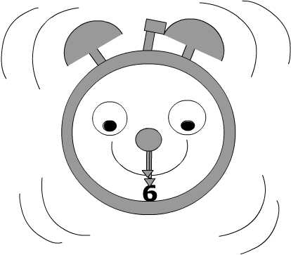
Monday. 6:30 a.m. The clock goes off and suddenly stops because I’ve just bought it a ‘flight’ ticket under the bed.
‘Honey! Wake up or you’ll be late for school!’
‘Five more minutes dad!’, meaning ‘Only a quarter of an hour!’.
I open one eye and because it’s too dark I close it right back as it was. Thanks to my ‘early’ dog, who’s bitten my toes hungrily, I have to get out of bed. I’m not wide-awake but I know my house by heart, so it’s not necessary to open my eyes. Too bad that I don’t know where my dog’s toys are because I’ve just stepped on one of his plastic bones and my dorsal part is not too happy about it(nor are my neighbours). And as if it wasn’t enough I miss the bathroom door and embrace the wall : ‘Why doesn’t it get out of my way?’. Now I’m really awake!
I get dressed in no time and before leaving I take my chance with dad:’ Have I told you how much I love you? I heard that schools are closed today!’
‘I love you too pumpkin but you should wash your ears better! Good luck with school!
Outside it’s freezing but it’s dark, so, on my way to school I get to dream some more(with my eyes open this time!).
‘Finally, school! Translation :’ Finally, chairs, benches and places to sleep!’
But today is not my lucky day and when I almost reach the door, the school bell rings and the doorkeeper closes the door, and here I am, outside, measuring it’s dimensions.
I manage to get inside. The teacher hasn’t entered the classroom so I sit on my chair, I put my head on the desk and close my eyes. ’Boy, I could use a pillow right now!’
Isn’t this a perfect morning?! Oh, I forgot to tell you that we also had a math test !
***

